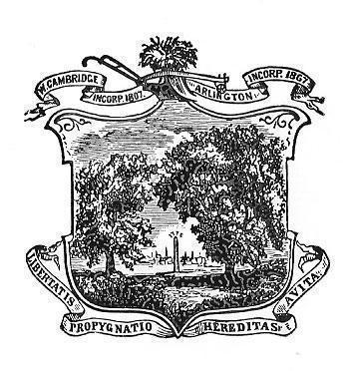

Arlington Youth Health and Safety Coalition

September 2021 Minutes

Date:September 20, 2021  
Time: 5:30- 6:30pm  
Location: Virtual (via Zoom)

Staff Present: Karen Koretsky

Attendance: Cindy Bouvier, Max Ballerini, Sarah Augood, Colleen Leger, Pat Egan

**Introductions**

and review of highlights from individual summer

**Minutes**

Attendees reviewed the June meeting minutes. Sarah moved to approve, Cindy seconded, all approved the June meeting minutes

**Committee Updates:**

**Coalition Direction:** The Town is seeking a Coalition Director and interviewing qualified candidates.

**YRBS:**

Results of the YRBS have been shared with HS and MS school leaders and Superintendent. Next they will be shared with parents and the general community.

**Parent Forums:**

GGC will be offered again. Making a determination if it will be in person or virtual. Waiting to hear from Cindy SC about her preference.

Cindy B would like information from Karen about digital literacy/citizenship presentations.

**Recruitment?**: Karen suggested that the Coalition should expand its membership. Can the new Director connect at PTO meetings and school open houses?

**Student recruitment:** The AHS students are meeting to discuss recruiting new students. They attended the required club meeting at AHS this week. It would be good to have an eye on diversity. Same for ACHS.

HRC camp took place at the end of August. Future reporting on results?

Meeting adjourned at 6:30 pm.