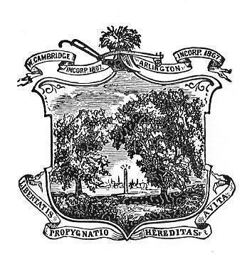

Arlington Youth Health and Safety Coalition  
April 2021 Minutes

Date:April 1, 2021  
Time: 5:30- 7:00pm  
Location: Virtual (via Zoom)

Staff Present: Karen Koretsky

Attendance: Max Ballerini, Andrew Conway, Cindy Bouvier, Kathy Hirsch, Sarah Augood, Carlene Newell, and Doug Grant

**Introductions**

**Minutes**

Attendees reviewed the March meeting minutes. Carleen moved to approve, Doug seconded, all approved the March meeting minutes

**Committee Updates:**

**YRBS:**

YRBS was completed by students at AHS and OMS on March 31, 2021. Approx. 830 AHS students and 671 OMS students took the survey. The YRBS has been surveyed for over 30 years in Arlington.

**Community Talk Grant:** AYHSC has been awarded a $750 dollar grant to address underage drinking. The Community Meeting and presentation about the access and littering of small alcohol bottles on May, 6th will be our community event.

**Students-**

Students have completed a community mapping project relating to tobacco and vape retailers in the community. They will present their findings in June 2021

**Kick Butts Day** happened virtually on March 31st. Carlene Newelll and Max Ballerini attended. Monica Bharel spoke. Arlington met with Senator Friedman and State Rep. Garballey. There was an awards ceremony and students met with legislators.

Drug Disposal in Arlington. Karen reported on the collection at the APD and National Drug take back on April 24th.

Mental Health Awareness month is in May.

Meeting adjourned at 7 pm.

Next meeting is a Community Stakeholders meeting scheduled for May 6th, 2021 at 5:30pm.