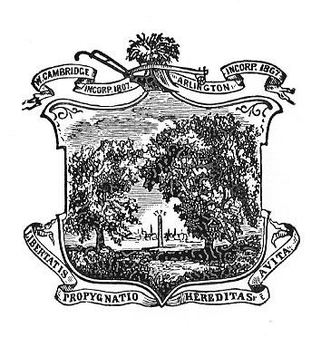
Arlington Youth Health and Safety Coalition
February 2021 Agenda

Date:February 4th, 2021
Time: 5:30-7:00 pm
Location: Virtual via Zoom email kkoretsky@town.arlington.ma.us to register

Agenda

- Introductions, Review & Accept January Minutes.
- Special presentations-Cindy Sheridan Curran-GGC, Testing in Schools
- Committee Updates
Students
Parents
Community Outreach
- What’s New

