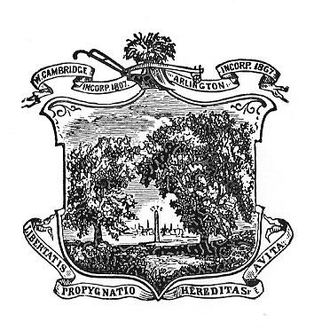
Arlington Youth Health and Safety Coalition
April 2021 Agenda

Date:April 1, 2021
Time: 5:30-7:00 pm
Location: Virtual via Zoom email kkoretsky@town.arlington.ma.us to register

Agenda

- Introductions, Review & Accept March Minutes.
- Special presentations-Students mini grant research project
- Committee Updates
Karen: Kick Butts Day, Community Talks Grant, Drug Disposal, Mental health Awareness Month in May
Students
Parents
Community Outreach-YRBS Info Session?
- What’s New

