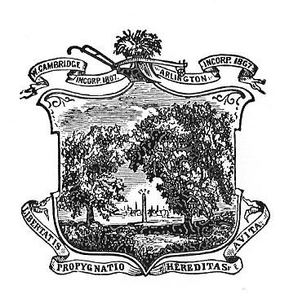
Arlington Youth Health and Safety Coalition
September 2021 Agenda

Date:September 20, 2021
Time: 5:30-7:00 pm
Location: Virtual via Zoom email kkoretsky@town.arlington.ma.us to register

Agenda

- Introductions, Review & Accept JuneMinutes.
- Committee Updates/Strategic Planning
Students
Parents
Community Outreach
- What’s New

