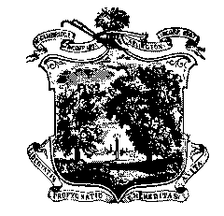

**Town of Arlington**

**Office of the Town Clerk**

Massachusetts Avenue

Arlington, MA 02476

Tel: 781-316-3070

JBrazile@town.arlington.ma.us

**Election Update – week of February 7th**

This information was shared via Town Notice email and to the TMM email list.

**Town Meeting Incumbent Deadline Extended to February 7 at 12 noon**

In consultation with Town Counsel, the Town Clerk has extended the deadline for current Town Meeting Members to file notice with the Town Clerk that they intend to run again. The deadline was Friday, Feb 4 at noon, but due to the weather it was not possible to receive mail or retrieve papers left in the town hall drop box.  Current Town Meeting Members have until noon on Monday, Feb 7 to submit their form (via drop box or email) and be placed on the ballot.

**Last Day to Request Nomination Papers, February 9 at 5 pm**

The Town Clerk will be at Town Hall until 5 pm on February 9 for the purpose of issuing nomination papers for both Town Meeting and Town-wide Office.

**All Nomination Papers Due Friday, February 11 at 5 pm**

The Town Clerk will be at Town Hall until 5 pm on February 11 for the purpose of receiving nomination papers.  Candidates are instructed not to use the Town Hall Drop Box on Friday.  Bringing papers directly to the Town Clerk ensures candidates have documentation of receipt.  In the event that bad weather closes Town Hall, look for updates on the Elections page and be prepared to return papers to the Public Safety Building where staff are on duty and can time stamp documents as received before the 5 pm deadline.  Email the Town Clerk in advance with questions.