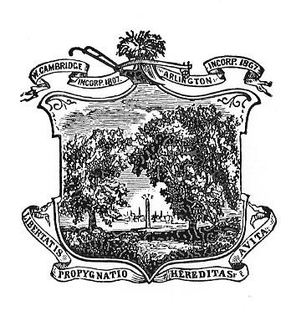
Zero Waste Arlington
June 2023 - Meeting Minutes

Date: 6/22/23
Time: 7pm
Location: Online Zoom Meeting

Attendees: Priya Sankalia, Scott Mullen, Amy Speare, Charlotte Milan, Larry Slotnick, Emily Dertz, Paul Goldberg, Margie Bell

Minutes

- Plastics Reduction Committee Update
  - Swan Place water filling station hopefully online in July - Larry is fixing
  - We’re working on signage - aluminum sign - mount on wall or post - $60 each. 12X18 sign planned
  - Amy made a motion to spend up to $400 on signage. Approved by committee
  - Get on Parks & Rec commission agenda to install sign. We could also consider the sign on the unit.
  - Larry is going to submit a formal proposal for the MWRA unit at Town Day
  - Addressing the boxed water carton sale at Stop and Shop - first have a dialog with them before we think about amendment to plastic water bottle ban to include boxed water.
- Website/comm subcommittee update
  - Amy updated on blogs - No plastics please theme - several blogs
  - ACMI talk of the town was a success! Jennifer and Emily were on that with Za owner being interviewed by James
  - 912 followers on FB now - people are engaging
  - Priya shared email received from NC about appreciative email about website
  - Mully suggested engaging 8th graders who proposed the pilot program. Mully will send link to Amy
  - Charlotte suggested engaging the high school summer interns
- Legislative subcommittee
  - Paul is writing the testimony for the EPR bills for paint, mattresses, and packaging. He updated the committee on the hearing and who opposed it. EPR bills on paint and mattresses have the best chance of passing.
  - They are following up on the zero waste caucus
  - We discussed what to put on the Policy page on the website - we could put just what the subcommittee is doing and then later we could update it with action alerts
  - Links to Mass Stewardship Council and other advocacy groups that are focusing on this.
- Charlotte Report
  - Summer intern program
  - Public works open
  - Getting guide out, setting it up
  - Town Day food service containers - hard to get the attention of the health dept.
- Events
  - National Night Out - sponsored by police dept - cookout with a DJ - for the kids living in Arlington Housing Auth housing - community event - resources for kids in town. We would need to have some fun activities.
  - We could partner with Cecily to put together an activity driven art installation.
- Town Day Planning
  - Pilot program to use reusable containers - we could set a goal but it might be tied to how many containers we have.
  - Schedule a Town Day planning subcommittee meeting - Priya will schedule for next week.
  - Collect reusable plastic water bottles for use at Town Day
- Larry suggested that we have our next meeting dedicated to Town Day planning and look at having it in person. Charlotte will book a room for us.

Meeting adjourned at 8:29

