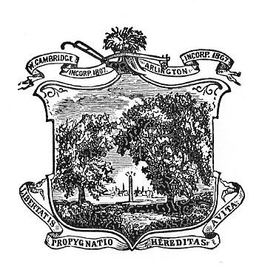
Zero Waste Arlington
July 2023 - Meeting Minutes

Date: 7/27/23
Time: 7pm
Location: Online Zoom Meeting

Attendees: Priya Sankalia, Scott Mullen, Amy Speare, Charlotte Milan, Larry Slotnick, Paul Goldberg, Margie Bell, Jennifer Campbell, Jim Ballin

Minutes

- The committee unanimously voted Margie Bell to the ZWA Committee.
- Town Day Planning
  - MWRA Water Source available and we have the support of the Town Day Committee
  - Collection of repurposed water bottles on going. They will be sanitized and we will make them available for people. We will also have paper cups
  - Health Dept is on board with the 250 person pilot for reusable containers. The containers need to be food code and sanitized. They want the restaurants to give them out
    - Use signup genius for signing up for the
    - Reach out to the restaurants
    - We need to order the containers within 10 days of Town Day or ideally before
    - We could involve the UU church - discussion on having bowls for their chili and pies
    - Need volunteers - maybe green teams? high schoolers? Charlotte will ask the interns
- Charlotte Update
  - Paint recycling! Kids are making a fundraiser for Arlington Housing Corp. Aug 9 - 5:00 - 7:00. They have 100 spots. Need to get the word out.
  - Republic is going to put orange stickers on contaminated recycling; over the limit etc.
- AoT update - 2 working. Town has put a bid for one for Thorndike - hopefully this Fall. They have purchased 2 additional units with the state money. Discussion on adding one in Robbins Park and whenever renovations come on.
- Jim Ballin - talked about his conversation with a Town Meeting member who is interested in a nip ban Article. He wants to start the discussion in Fall. Also black plastic - we need to discuss that.
- Paul provided an legislative subcommittee update.
  - The paint bill seems to be the most promising

Meeting adjourned at 8:29

